- Plot the points A(5,-2), B(-5,-2), C(5,2), D(-5,2) E(3,0), and F(0,3) on a coordinate plane.
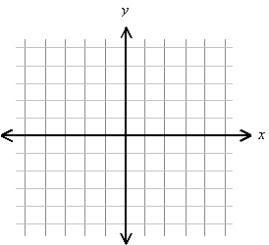
- Plot the points A(0,0), B(1,1), C(3,3), D(-1,-1), and E(-2,-2). Describe the set of all points of the form (a,a), where a is a real number.
- Describe the set of all points P(x,y) in a coordinate plane that satisfy the given conditions.
- x = -2 (b) y = 3 (c) x ≥ 0

(d) xy > 0 (e) y < 0 (f) x = 0

- Find the distance d(A,B) between A and B. (b) Find the midpoint of the segment AB.
- A(4, -3), B (6, 2) 5. A(-5, 0), B(-2, -2) 6. A(7, -3), B(3, -3)

7. Show that the triangle with vertices A(8, 5), B(1, -2), C(-3, 2) is a right triangle, and find its area.

8. Show that A(-4, 2), B(1, 4), C(3, -1), and D(-2, -3) are vertices of a square.

9. Given A(-3, 8), find the coordinates of the point B such that C(5, -10) is the midpoint of segment AB.

10. Prove that C is on the perpendicular bisector of segment AB. A(-4, -3), B(6, 1), C(5, -11)

11. Find a formula that states that P(x, y) is a distance 5 from the origin. Describe the set of all points.

12. Find all points on the y-axis that are a distance 6 from P(5, 3).

13. Find the point with coordinates of the form (2a, a) that is in the third quadrant and is a distance 5 from P(1, 3).

14. The table lists the number of daily newspapers published in the U.S. for various years.
Year | Newspapers
1900 | 2226
1920 | 2042
1940 | 1878
1960 | 1763
1980 | 1745
1993 | 1556
- Plot the data in the viewing rectangle [1895, 2000, 10] by
[0, 3000, 1000]
- Use the midpoint formula to estimate the number of
newspapers in 1930. Compare your answer with the true
value, which is 1942.

